QUE 1:- PRINT THE COMBINATION OF 3 DIGITS PROVIDED BY USERS

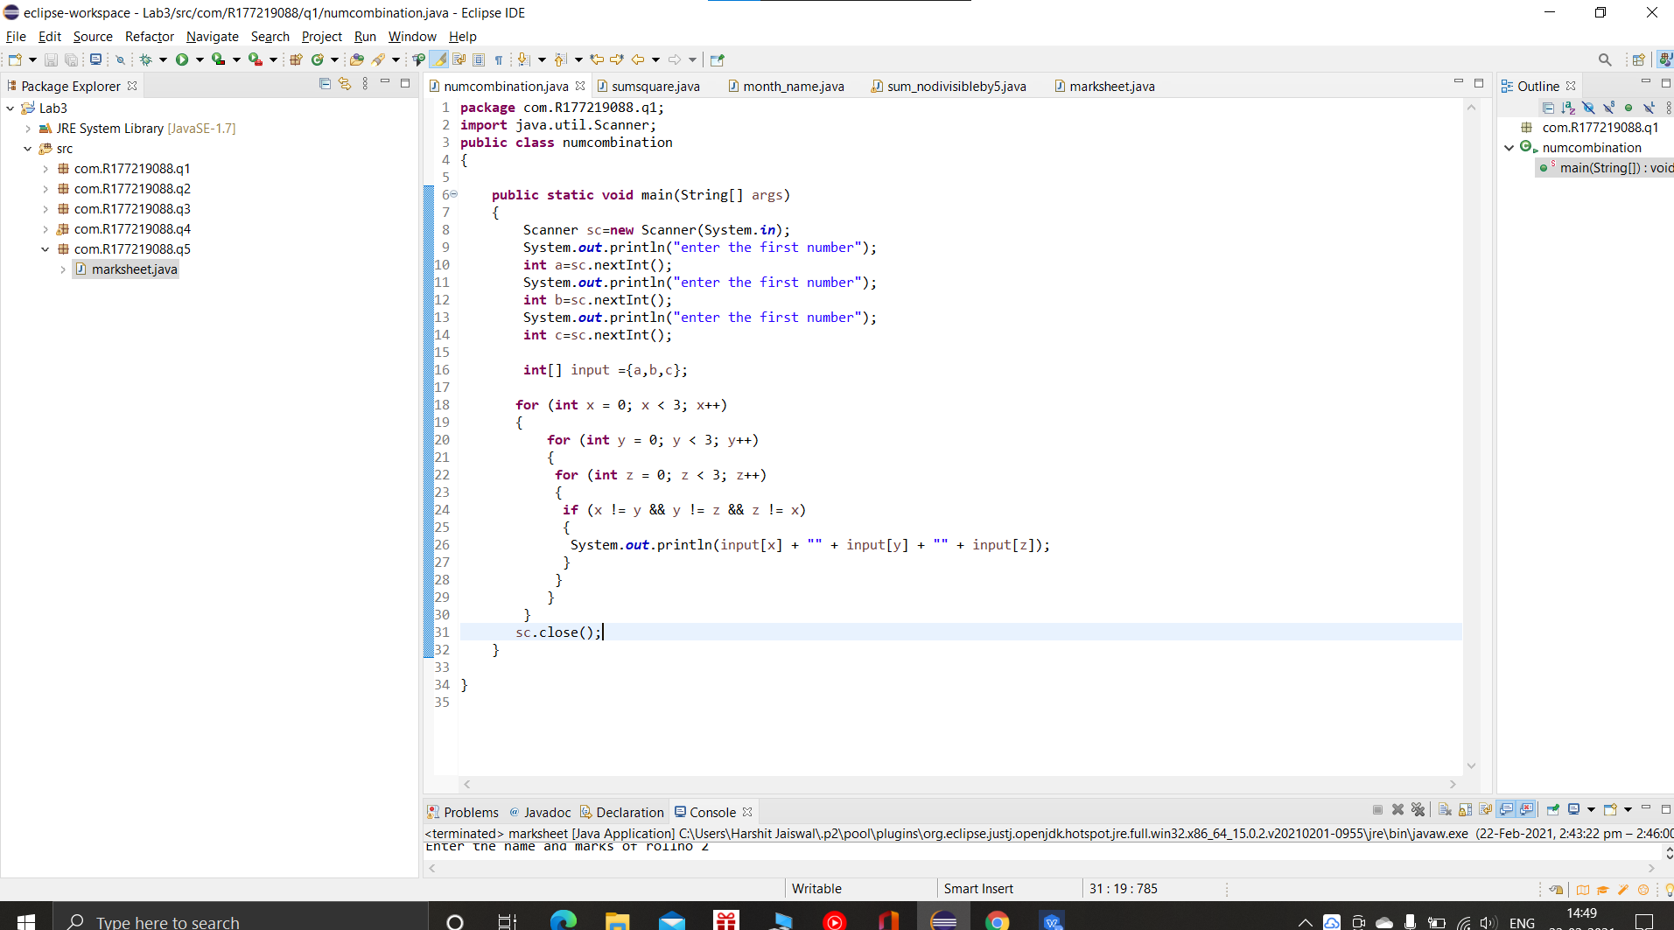

OUTPUT:-

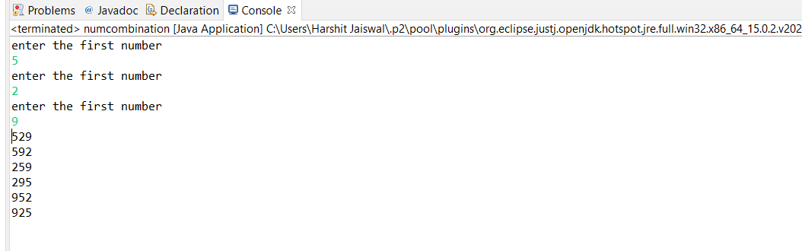

QUE 4:- PRINT THE SQUARE AND THEIR SUM OF 10 NUMBERS PROVIDED BY USERS

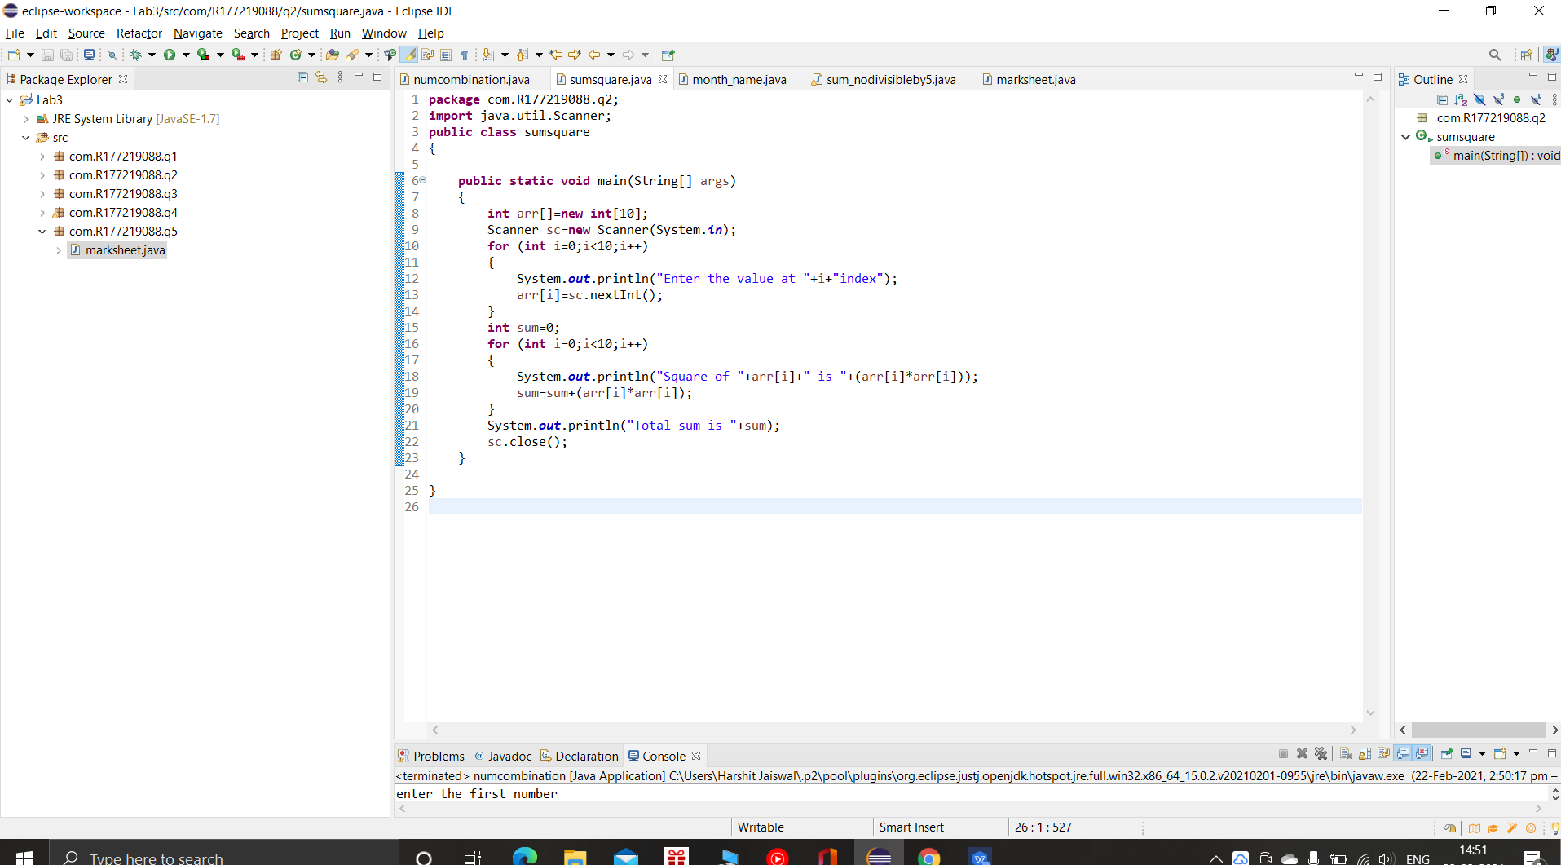

OUTPUT:-

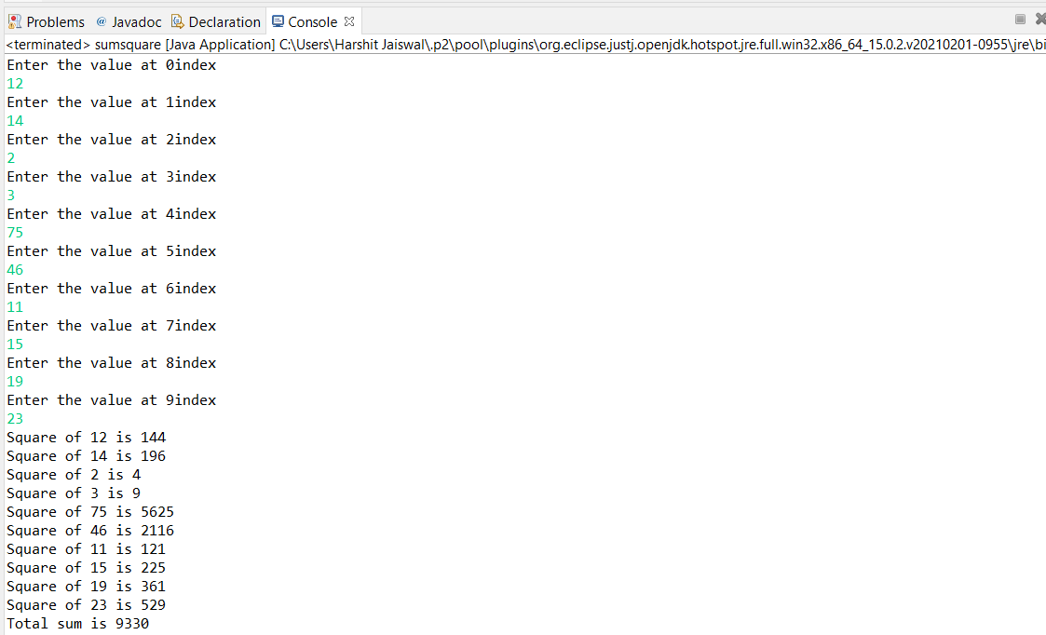

‘QUE 3:- PRINT THE NAME OF MONTH CORRESPONDING TO MONTH NUMBER

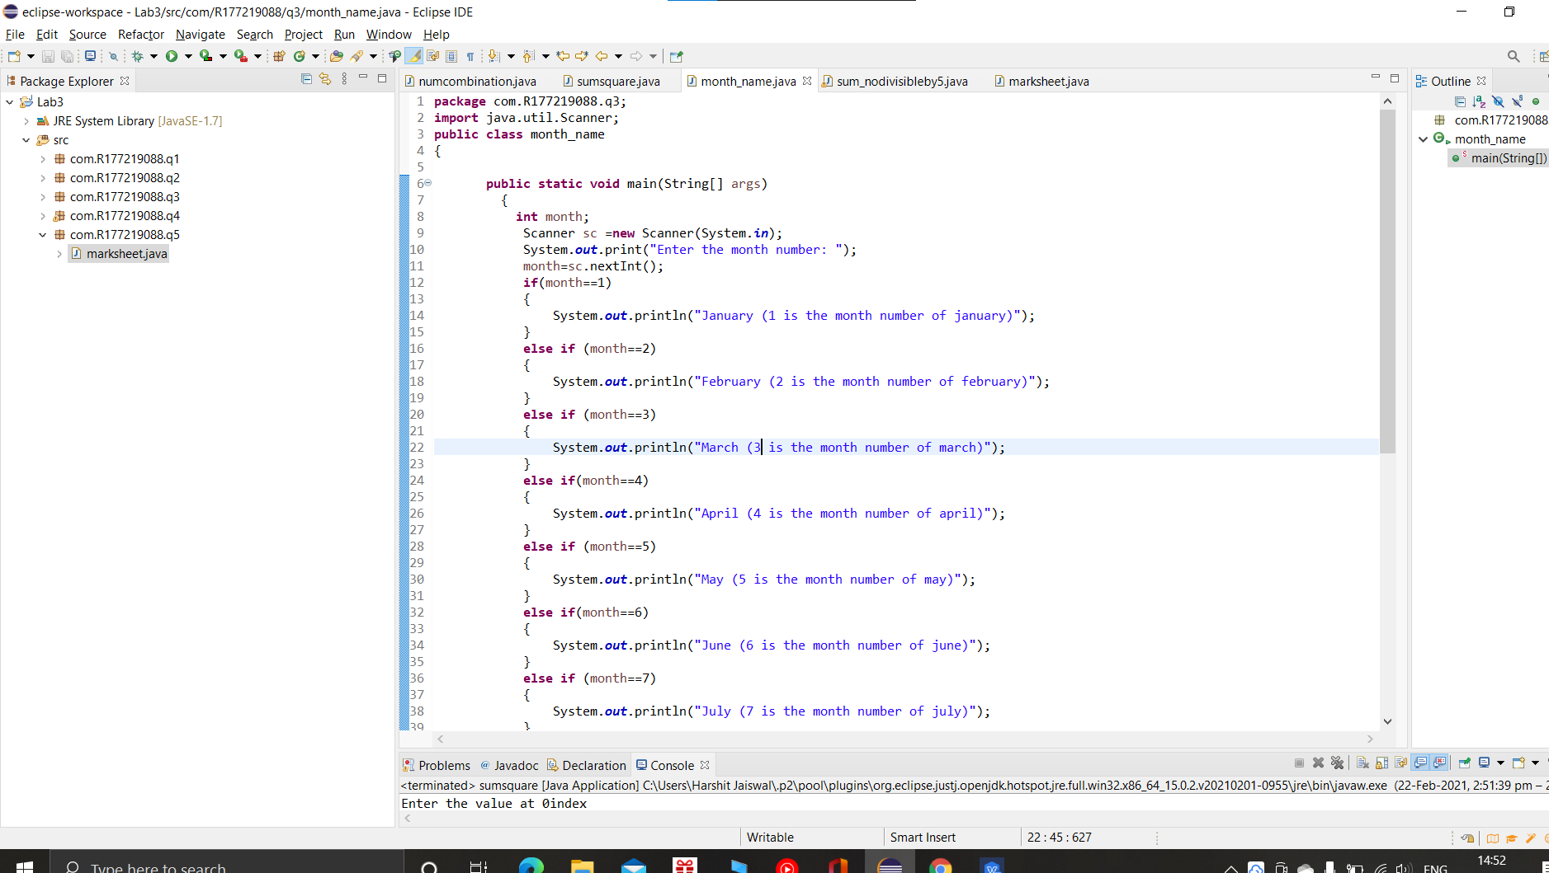

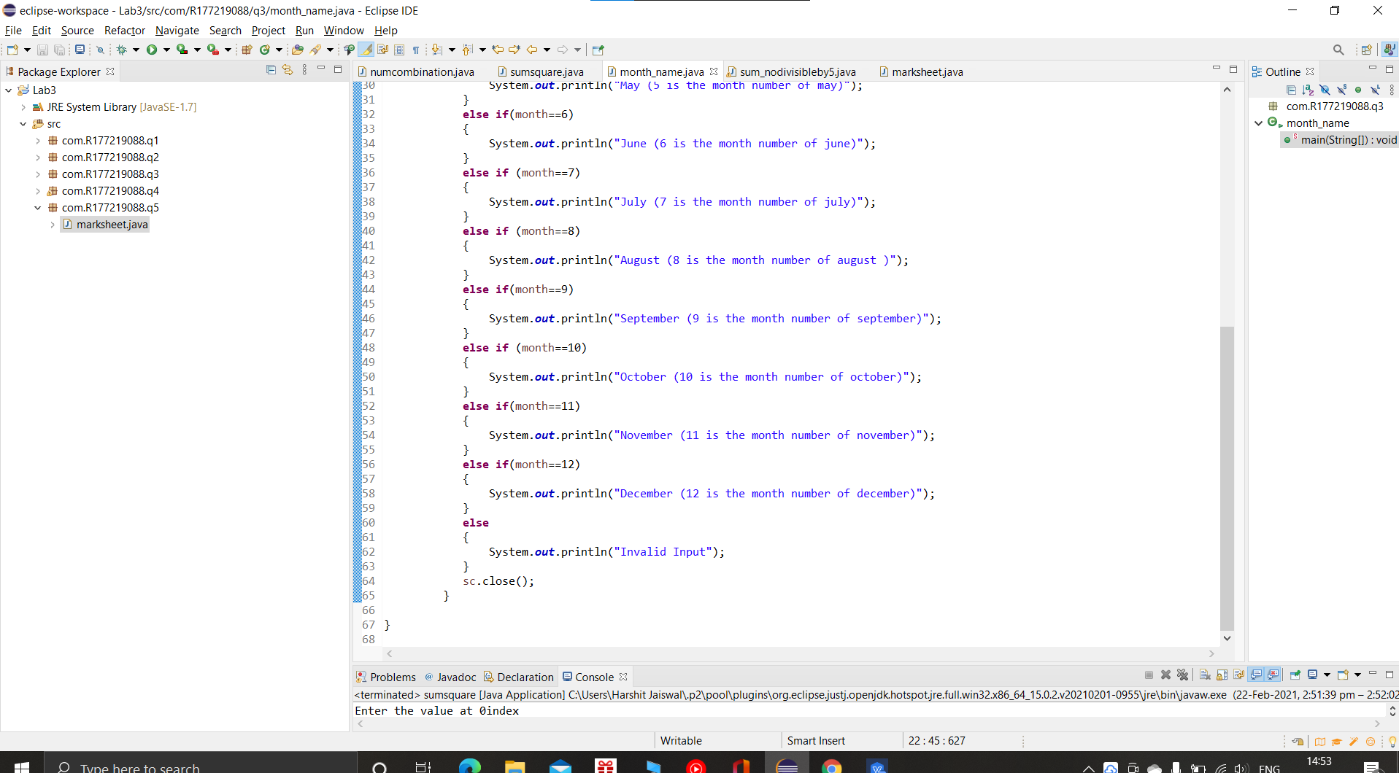

OUTPUT:-

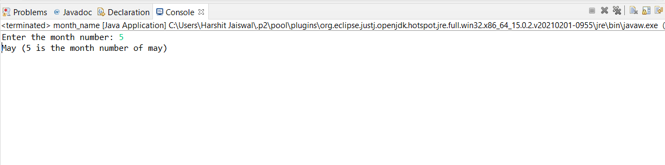

QUE-4:- PRINT THE NO IN BETWEEN 45 AND 250 WHICH ARE DIVISIBLE BY 5

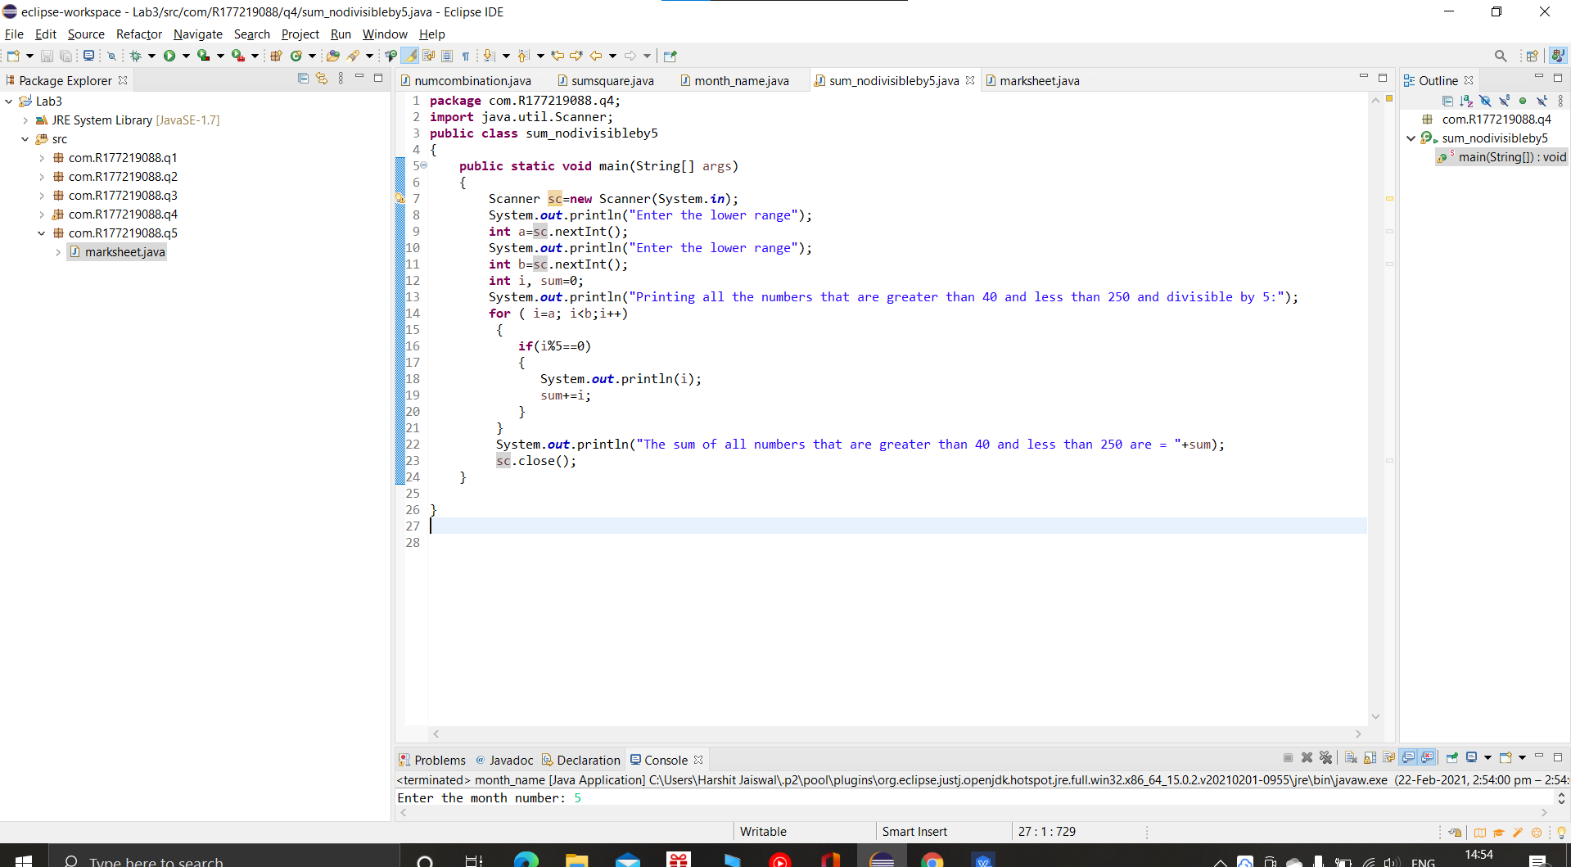

OUTPUT:-

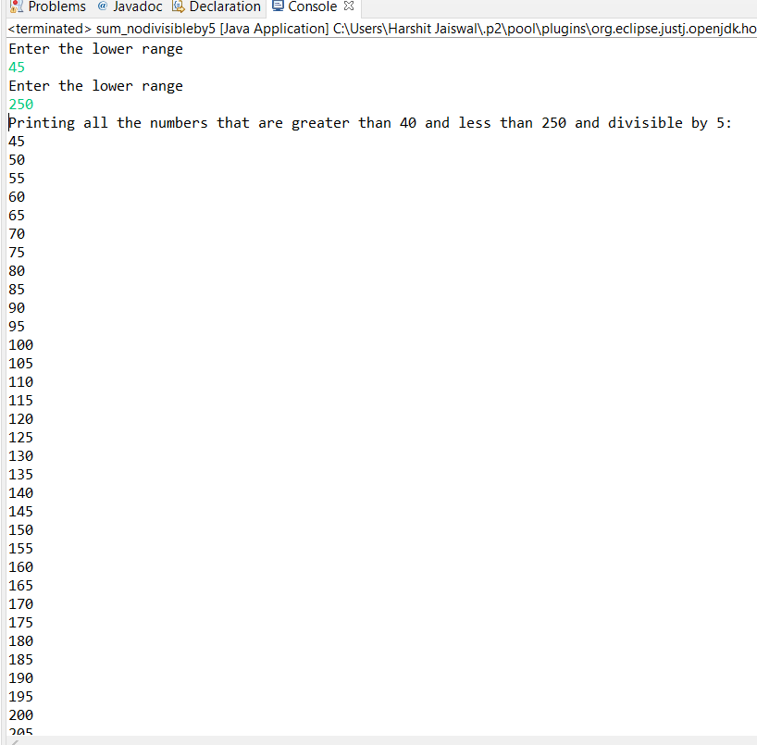

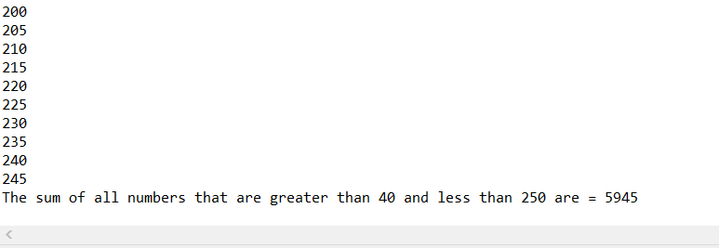

QUE -5:- PRINT THE MARKSHEET OF 10 STUDENTS

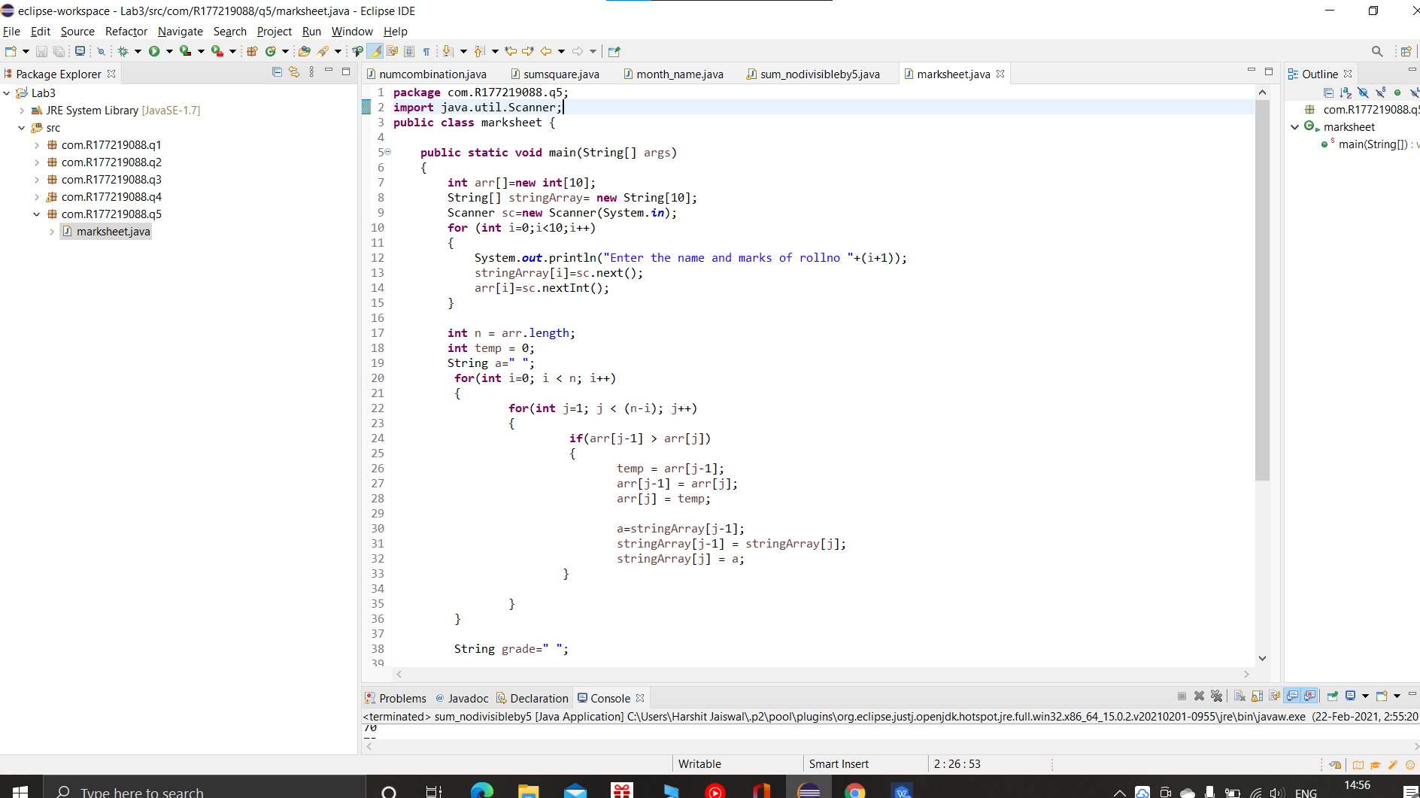

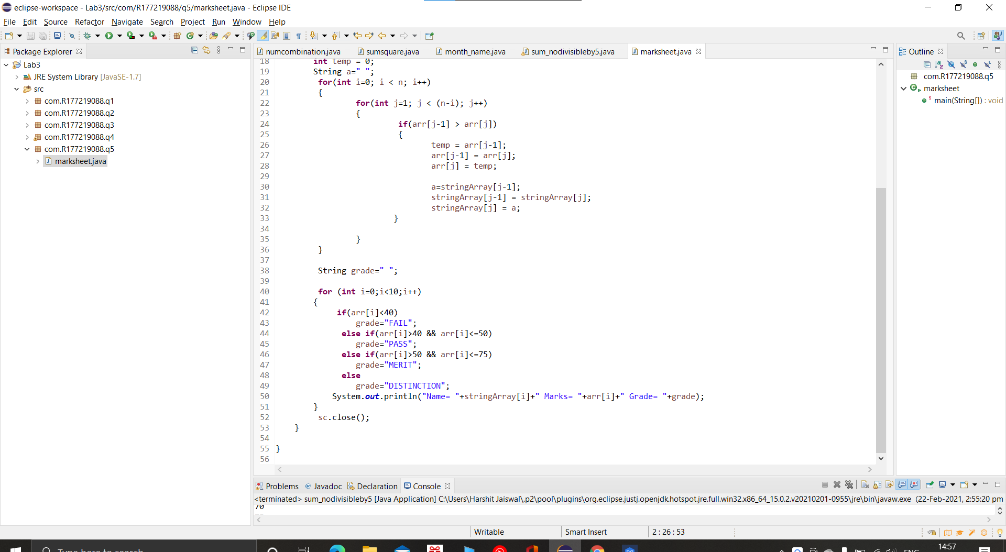

OUTPUT:-

